**TABLE MENU PROJECT UML**

**CLIENT PAGE**

QR code redirects customer to this page.

**CATEGORY MENU**

Application has 5 Categories i.e Fries, Juice, Pizza, Burger and Drinks

**FOOD ITEM**

Customer Selects food from different categories.

For each “Add To Cart” button will direct the customer to cart.

**ADD TO CART**

**CHECK OUT**

Customer complete order by submitting Username and table no.

**TABLE MENU PROJECT UML**

**ADMIN MODULE**

**Admin’s Dashboard**

**LOG OUT**

Administrator - allows the user to access less compared to manger position on the application i.e,

* He/she can create, update and delete the items in the **Menu**, **Orders** and **personal** **settings** only**.**
* He/she cannot view the **total** **sales** from the counter made for each item/product delivered.

Manager - allows the user to manipulate everything on the application i.e,

* He/she can create, update and delete the items in the **Menu**, **Administrators**, **Orders**, **Subscriptions.**
* He/she can view the **total** **sales** from the counter made for each item/product delivered.
* He/she is responsible for adding and updating **Admin** information including roles to take.
* He/she can manage the subscriptions list and is responsible of the information to the subscribers.

NOTES

* Dashboard
* All Menus
* Orders
* Administrators
* Subscriptions
* Settings

**Manager’s Dashboard**

The manager has all the privileges on this application and can change anything.

**MANAGER**

* Dashboard
* All Menus
* Orders
* Settings (Personal)

The manager has all the privileges on this application and can change anything.

**ADMINISTRATOR**

At this point we have to levels of Login i.e Manager and Admin.

**LOGIN PAGE**

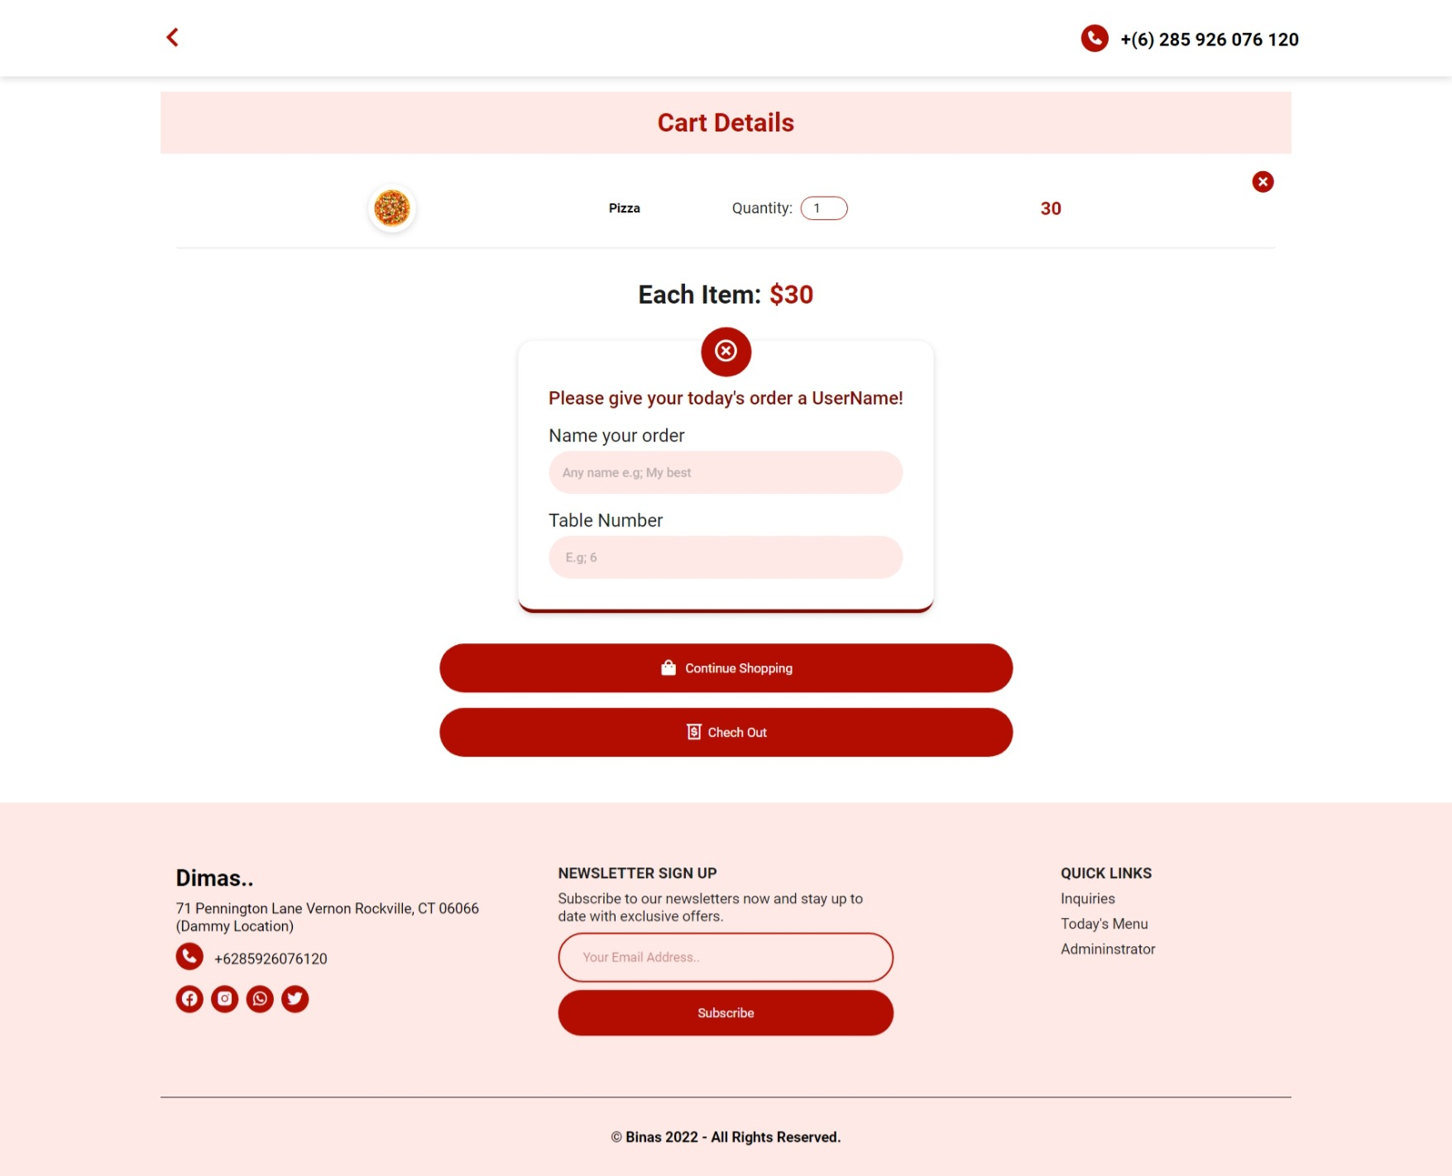

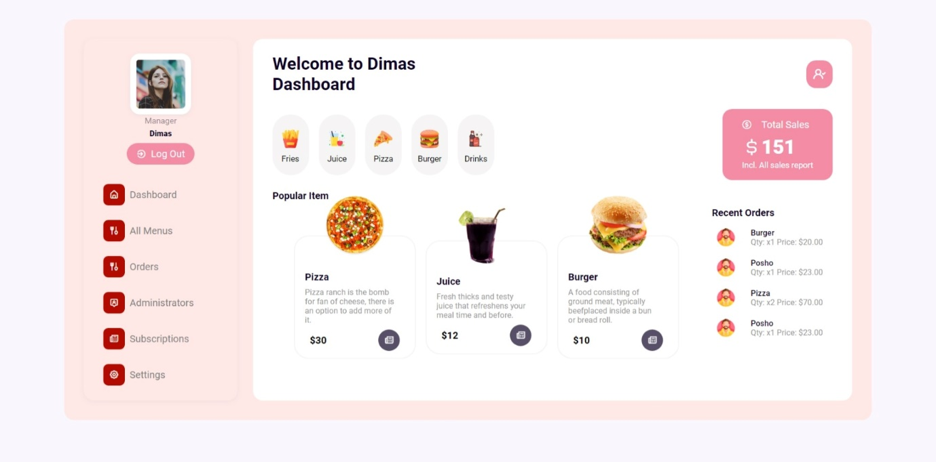

**DISCLAIMER:** This project is irrelevant to the portfolio project, I just wanted to illustrate how you can link your own CV and download it successfully.

But in case you are interested, please Download it from this video link below.

Project Link: <https://www.youtube.com/watch?v=vWvTdh1MAJc&t=360s>

Thank you!

IsraTech